The Legend of the Old Kingdom of Hyrule

To better understand this untold story of the Hero of Legend, it is imperative to reach into legend surrounding the Triforce and the Old Kingdom of Hyrule. This story has been passed down through countless generations to the point where many doubt the accuracy of details. However, the overarching events have always remained constant.

This is a legend that is hardly spoken of anymore. To some, it is a history of the fall of the Old Kingdom of Hyrule. To others, it is merely a myth. The legend begins with the creation of the world...

The Creation

Long ago, the world did not exist. Only the three goddesses did. Their names were Farore, the goddess of courage, Nayru, the goddess of wisdom, and Din, the goddess of power. Together, they decided to create a world which would be inhabited by many species of their creation.

They decided that it would be best to split the task among themselves. Farore was in charge of creating the atmosphere. So Farore created the atmosphere. Nayru was in charge of creating the water. So Nayru created the water. Din was in charge of creating the land. So Din created the land. They looked upon their creation and saw that it was indeed what they had envisioned.

It was then time to create the inhabitants of this new world. Once again, they split up the task. Farore made the Hylians, Nayru made the animals, and Din made the Zoras. Each goddess was put in charge of her species.

The last thing that the goddesses created was a kingdom to help start the world off in the right direction. Together, they created a kingdom and placed each of their species within that kingdom. They called it the Kingdom of Hyrule.
The Triforce

This new world, although made by the goddesses, was not perfect. For every bit of good there is in the universe, there is an equal amount of evil. The evil that balanced the good of the goddesses was the darkness. The darkness constantly attempted to bring down the newly created world, so the goddesses created the Triforce to keep the darkness at bay. Each piece of the Triforce was created by a goddess and the piece that they created reflected their individual trait. These individual pieces of the Triforce were then known as the Triforce of Courage, the Triforce of Wisdom, and the Triforce of Power.

This is the part of the story where it is explained why the Triforce grants wishes, but that part of the legend has become lost. Some believe that Triforce is a living thing and grants wishes on its own accord. Others, however, believe that the goddesses bestowed that power upon the Triforce themselves.

With the Triforce in place, the darkness was driven back to the point of near extinction and it was thought that never again would the darkness return. But they were wrong.

The Fall

Over the next many years, the goddesses visited the Kingdom of Hyrule by taking on various forms to blend in with the world. On one particular trip, the goddess Din took on the form of a Hylian to experience what it was like to live as a Hylian. This not only included the livelihood of the Hylians, but also the emotions such as anger, happiness, and love. It was that last one that began the decline of the Old Kingdom.

While in Hylian form, Din fell in love with a traveler whose name name was Argon Fond. Together, they were happy. But Din was blinded by love and failed to foresee the day when Argon would betray and corrupt her with darkness. Argon locked away her soul and took control of her body and powers to start an uprising against the other goddesses. Through Din, Argon gathered many followers and promised them all power and wealth beyond their wildest dreams.
Naturally, Farore and Nayru gathered followers of their own and fought back against the evil Argon Fond. For many years, the Kingdom of Hyrule played host to war and devastation. Many lives were lost, many sacrifices were made, and many dreams were shattered. But the war was just a diversion.

Argon used the war as a distraction so that he would be free to search for the hidden temple that housed the Triforce. Using Din, he managed to find it and barricaded himself within the temple walls so that he could get access to the Triforce and use it for his evil desires.

Argon then attempted to use the Triforce, but was stopped in his tracks by Farore and Nayru for they had discovered his true intentions long before Argon had even reached the temple.

After a major scuffle that left the temple and most of Hyrule in ruins, Argon was defeated. The Triforce was then used by Farore and Nayru to remove Argon from Din's body and banished him back into the darkness from which he came.

However, Argon was still in possession of Din's soul when he was banished and although he was no longer able to possess her body, Din was still trapped in limbo because her soul had not been returned.

The Aftermath

That Kingdom of Hyrule is now referred to as the Old Kingdom of Hyrule because after the Great War, it was in ruins. The new, and current, Kingdom of Hyrule was built upon the Old Kingdom and while it was being rebuilt, Farore and Nayru searched high and low for the whereabouts of Din's lost soul.

It was never found.

During the following years, the stories of the Great War became legends. And the legends became myths. No one knows much about what happened to the goddesses after the fall of the Old Kingdom of Hyrule. No one even knows if they're still searching for Din's lost soul.

As for the Triforce?
It is said that Farore and Nayru locked away the Triforce and split the key so that only a worthy person could ever find and use the Triforce. Where are the Key Fragments?

That is the question very few dare to ask.
1. Before You Begin Your Quest

Title Screen

To start the game, simply double-click “Zelda Guardian of Hyrule.exe” and you will be presented with a title screen that looks like the one on the right.  To begin, press the space bar to move on to the next screen below. | 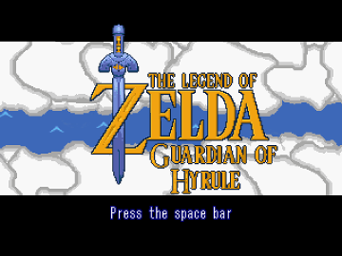

Player Select Screen

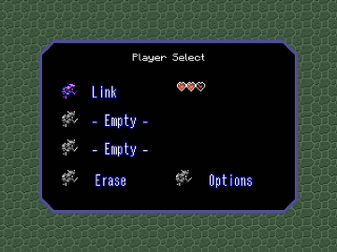 | The game can save up to three separate players. When playing for the first time, you can select any one of the three files. To do this, use the arrow keys to move the fairy cursor next to the desired slot and press the space bar to accept.  If you wish to continue a file, move the fairy next to the desired slot and press the space bar to immediately jump back into the game.
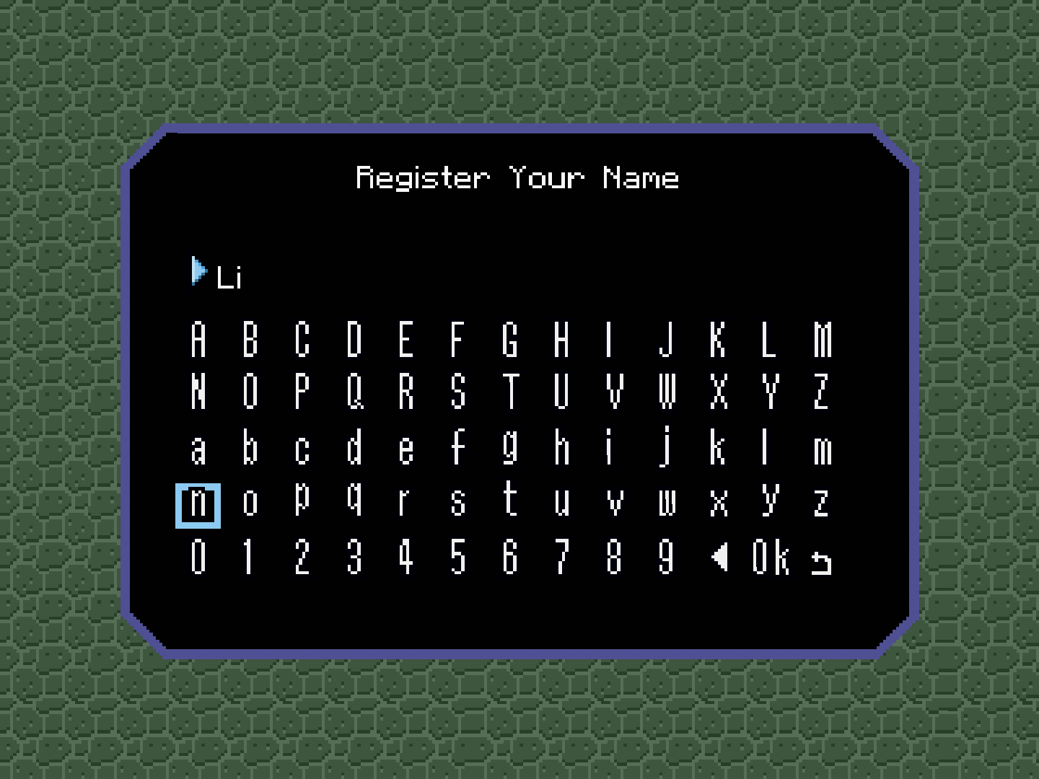 | At the Register Your Name screen, you will be able to input your name. Use the arrow keys to move the cursor through the alphabet and press the space bar to input the selected letter/number. When done, move the cursor to OK and press the space bar. You can delete a letter/number by selecting the left arrow or return to the Player Select screen by selecting the looped arrow.

Erase a Player
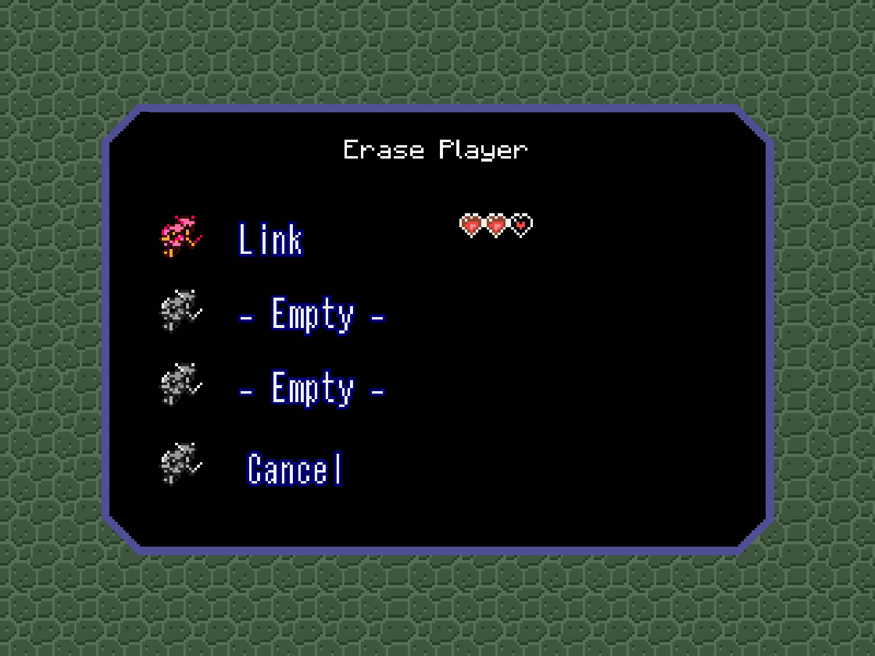 | Should you find that all three player spots have been taken up or you wish to remove a player from the list, you must erase the player. To do this, select ERASE and you will be presented with a screen like the one on the left. Another indicator is that your fairy cursor will now flash red instead of blue.  If you've changed your mind or accidentally selected ERASE, simply select CANCEL to return to the Player Select screen.
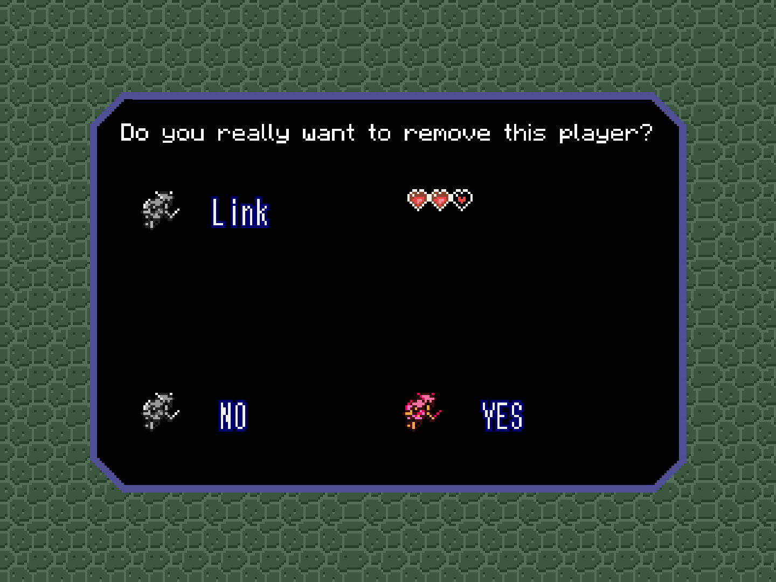 | Move to the fairy next to the file you wish to remove and press the space bar. You will be asked "Do you really want to remove this player?" Select YES to remove the player. Select NO if you do not.  NOTE: Erasing a player is permanent and cannot be undone!

        - The Main & Pause Screens

Main Screen

